

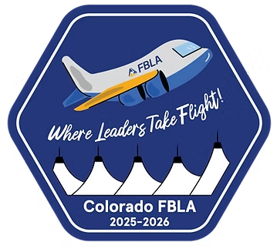

Future Business Leaders Soar

at the 2026 Colorado FBLA

State Leadership Conference

Aurora, Colorado, (April 2-4, 2026)- ### members of the Colorado Future Business Leaders of America from (insert school name) had the opportunity to attend and compete at the 2026 FBLA State Leadership Conference. From forging unforgettable bonds to elevating professionalism and showcasing leadership skills, students seized opportunities to advance their futures alongside FBLA knowledge to bring back to their schools and local communities.

This three-day conference also granted members a series of educational workshops and community service challenges to further enhance their experience.

A shared passion and deep-rooted respect for service, education, and progress brought together thousands of students and advisers from across the state for this conference. Equipped with a strong understanding of business acumen, members were able to compete in over 70 different competitive events, ranging from objective tests to role-plays and speeches.

Overall, (insert school name) brought home many awards and honors for our members and school throughout this conference including:

(List Awards/Honors Here)


Colorado FBLA, a chartered member of National FBLA, is a registered 501 (c)3. Their mission is to bring business and education together in a positive working relationship through leadership and career development programs. Colorado FBLA inspires and prepares students to become community-minded business leaders in a global society through relevant career preparation and leadership experiences.

If you would like more information, please contact (Your Name) at (School Phone or Email).

