New Member Induction Ceremony

Purpose

The New Member Induction Ceremony is used to inform and inspire new FBLA members about the purposes of our organization while providing an opportunity to develop presentation skills for officers.

The presentation of the crest, displayed below, is part of this ceremony.
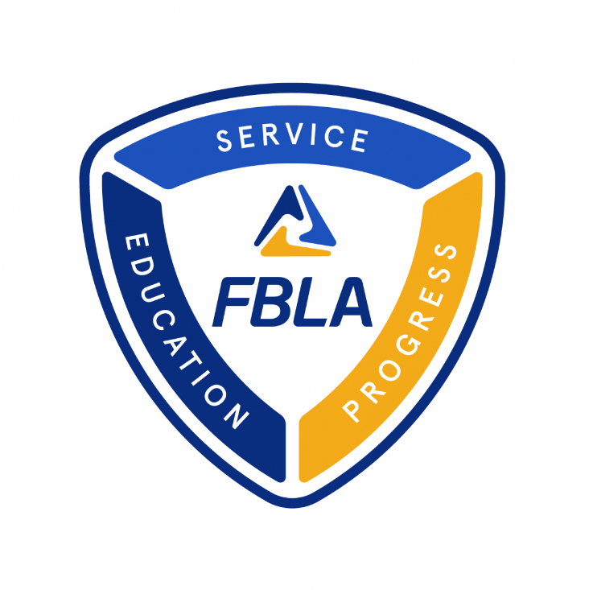

Methods of Presentation

- Many chapters make a large emblem on construction or tag board. They then cut out the different pieces and affix them to the tag board with Velcro or tape.
- Another option is to create a PowerPoint presentation of the FBLA Crest Ceremony

As an officer speaks about each part, they place the “puzzle” of the crest. Once the ceremony is done – you will have a completed crest!
Script

Chapter President: (Raps the gavel once for the group to come to order)

Welcome to the Induction Ceremony for Future Business Leaders of America (FBLA) .

FBLA’s mission is to inspire and prepare students to become community-minded business leaders in a global society through relevant career preparation and leadership experience.

I would like to start by introducing each of our local chapter officers. (Have each officer stand as the Chapter President introduces each officer by name and title).

Thank you, officers.

Would our chapter secretary please bring those members who would like to join our chapter forward?

Chapter Secretary: (Guides New Members to the front of the room as a group) Mr. or Madam President: These candidates have expressed a desire to become members of the (name) chapter of Future Business Leaders of America (FBLA).

Chapter President (to the candidates). We accept you as candidates for membership in the (name) chapter of Future Business Leaders of America. Before you become members, however, let us consider the three parts of our Delta logo in the middle of our

(Reporter Displays Delta below)

The Delta represents:

- FBLA’s commitment to the ideals of service, education, and progress.
- FBLA’s three divisions: Middle School, High School, and Collegiate.
- The change and progress our student members experience as part of FBLA.
- The importance of each piece of the whole coming together to achieve success.

Let’s take a closer look at the three words on our crest, starting with service.

Chapter Vice President:
The word “service” donates the idea that every individual should be interested in a take responsibility for promoting better social, political, and family life.

The “SERVICE” element of the crest is displayed by the Chapter Reporter.

Community Service activities help the chapter get involved using our business leadership skills to contribute directly to the school and community .

Members recognize the importance of being responsible citizens and form networks with business and community leaders.

They also gain the experience of managing a project outside of the classroom environment.

Our FBLA National service project is the March of Dimes. We have had a successful partnership for more than 45 years. During that time, our members have raised over $15 million dollars.

Chapter Treasurer: The word “education” is symbolic of the idea that education is the right of every individual.

The “EDUCATION” element of the crest is displayed by the Chapter Reporter.

Education activities increase a members’ knowledge of various business careers, providing valuable career orientation and goal setting opportunities. Guest speakers, panel discussions, and business-related presentations are used as instructional tools in chapter meetings and activities. Field trips and business tours demonstrate first-hand what has been discussed in the classroom or at a meeting. Many chapters develop special events to observe American Free Enterprise Day which is November 15. Some of the activities that they plan include job shadowing, mock interview experiences, and special business guest speakers.

Chapter Parliamentarian: The word “progress” represents the challenges of tomorrow which depends on mutual understanding and cooperation of business, industry, labor, religious, family, and educational institutions and by people of our own and other lands.

The “PROGRESS” element of the crest is displayed.

Our members are making progress by partnering with business, education, and civic organizations to earn scholarships, partnerships, and opportunities.

Chapter Vice President: Now, let’s focus on the words that make up our name, beginning with Future.

The word “future” reminds us that the future of the world depends upon the quality of leadership that we are able to produce and we in FBLA will be the business leaders of the future. We must learn to recognize the situation in which our individual talents will be useful.

The “FUTURE” element of the crest is displayed by the Chapter Reporter.

In FBLA, we will find the tools to prepare us for the future. We will profit from the experiences of others, those who have preceded us, as well as our advisers and others with whom we network. Our studies and activities will help us meet changing conditions and further our understanding of the world’s varied economic systems.

Chapter Secretary: The world of “business” is our world. To be successful in business, a person must be educated both formally and informally in business methods and procedures and in the basic principles of our economic system and government.

The “BUSINESS” element of the crest is displayed by the Chapter Reporter.

We realize the importance of education and training in business methods and procedures. We embrace the entrepreneurial spirit and free enterprise system that makes the American Dream accessible and possible for everyone. We appreciate the role of business in our daily lives.

Chapter Treasurer: The word “leaders” represent the search for knowledge in order for us to become better citizens. This knowledge will prepare us for the great task of leadership ahead.

The “LEADERS” element of the crest is displayed by the chapter reporter.

Optional Additional “Leaders” Message: The future of our country depends on the quality of Leadership. Leadership implies honor, vision, innovation, dependability, tact, competence, discretion, and integrity. A leader must listen, withstand criticism, and be flexible. A leader accepts failure in stride but is willing to profit from it. As members of Future Business Leaders of America, it is our duty to prepare for the enormous responsibility of business leadership in the years ahead.

Chapter Vice President: Finally, we think about America. The future of America depends on our generation. We should pledge ourselves to use the abilities that we have to make America a better place for everyone.

The “AMERICA” element of the crest is displayed by the Chapter Repeorter.

If the United States is to remain a world leader, intelligent young men and women are needed to guide our country by studying our past, analyzing our present, and preparing for the future.

The initiative and success of leaders in business will help us shape the future of America. Through FBLA, we will strive for leadership in the field of business, thereby helping to strengthen our great nation.

Chapter President All the words together stand for Future Business Leaders of America. The crest stands for our organization which provides opportunities for each member to become a leader of tomorrow.

Raps the gavel and presenting members are seated.

Optional Conclusions to the FBLA Crest Ceremony

Recite the FBLA Pledge

Chapter President
Please rise, raise your right hand, and join me in reciting the FBLA Pledge:

Wait for all members to stand.
Display the FBLA Pledge or distribute copies if possible.

I solemnly promise to uphold the aims and responsibilities of the Future Business Leaders of America and, as an active member, I shall strive to develop the qualities necessary in becoming a responsible business leader.

Recite the FBLA Creed

Chapter President Please rise and join me in reciting the FBLA Creed:

Wait for all members to stand.
Display the FBLA Creed or distribute copies if possible.

I believe education is the right of every person.

I believe the future depends on mutual understanding and cooperation among business, industry, labor, religious, family and educational institutions, as well as people around the world. I agree to do my utmost to bring about understanding and cooperation among all of these groups.

I believe every person should prepare for a useful occupation and carry on that occupation in a manner that brings the greatest good to the greatest number.

I believe every person should actively work toward improving social, political, community and family life.

I believe every person has the right to earn a living at a useful occupation.

I believe every person should take responsibility for carrying out assigned tasks in a manner that brings credit to self, associates, school and community.

I believe I have the responsibility to work efficiently and to think clearly. I promise to use my abilities to make the world a better place for everyone.

Finally, many chapters present new members with certificate of membership, their membership card, or a FBLA pin.

