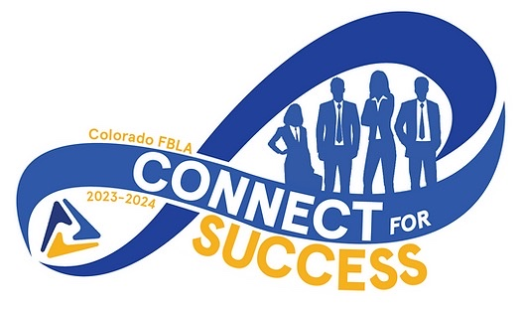
Contact: (Your Name)
Telephone: (School Phone)
Email: (School Email)
Website: www.coloradofbla.org

FOR IMMEDIATE RELEASE
Success at the 2024 Colorado FBLA State Leadership Conference

Aurora, Colorado, (April 1-3, 2024)- ### members of the Colorado Future Business Leaders of America from (insert school name) had the opportunity to attend and compete at the 2024 FBLA State Leadership Conference. Throughout the conference, members had the opportunity to make connections with members across the state, network with business professionals, showcase their talents and skills, and become better leaders within their schools and communities. This three-day conference provided members with various educational workshops and the opportunity to get involved in community service projects.
Thousands of students and advisers from across the state were able to attend this conference, which ignited their passion for business. Members were able to compete in over 70 different competitive events ranging from objective tests, to roleplays, to speeches.
Overall, (insert school name) brought home many awards and honors for our members and school throughout this conference including:
(List Awards/Honors Here)
Colorado FBLA, a chartered member of National FBLA, is a registered 501 (c)3. Their mission is to bring business and education together in a positive working relationship through innovative leadership and career development programs. Colorado FBLA inspires and prepares students to become community-minded business leaders in a global society through relevant career preparation and leadership experiences.

If you would like more information about this topic, please contact (Your Name) at (School Phone) or at (School Email).

