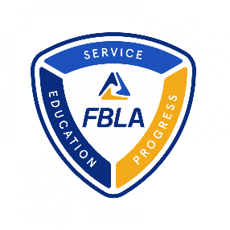
Adviser Monthly Implementation Guide (FBLA Middle School Division)
MEMBERSHIP MANAGEMENT
- Register returning and new members for your chapter at my.FBLA.
- Sign the Data Usage Agreement
- Share chapter news or an article pitch for a future issue of Tomorrow’s Business Leader. We are particularly interested in stories and article ideas surrounding the topics of community service projects, leadership, and career exploration
Submit Chapter News
- Register for NFLC and/or state-sponsored fall leadership conferences
  - A special Middle School Track is being officer at both NFLCs
  - Don’t for to make housing accommodations!
NFLC Details
MERIT AWARD
- Set an action plan to participate in the Merit Award Program which is a membership engagement focused challenge in where chapters build a basic program of Work through a calendar of activities throughout the year
RECRUITMENT
- Plan a social activity to help recruit and retain members
- Share the digital copy of the September issue of Tomorrow’s Business Leader with your students
LEAD AWARDS
- Get students connected and acclimated with the FBLA Learning Center
STUDENT CHALLENGES
- Register for Stock Market Game Registration Begins on October 10
MARCH OF DIMES
- Register for and attend the October 19 March of Dimes Kickoff Webinar
- Create a March of Dimes Project Planning Committee
- Plan an event for a chapter meeting to educate your members about the March of Dimes
COMPETITIVE EVENTS
- Work with members to identify their competitive event focus

OCTOBER

