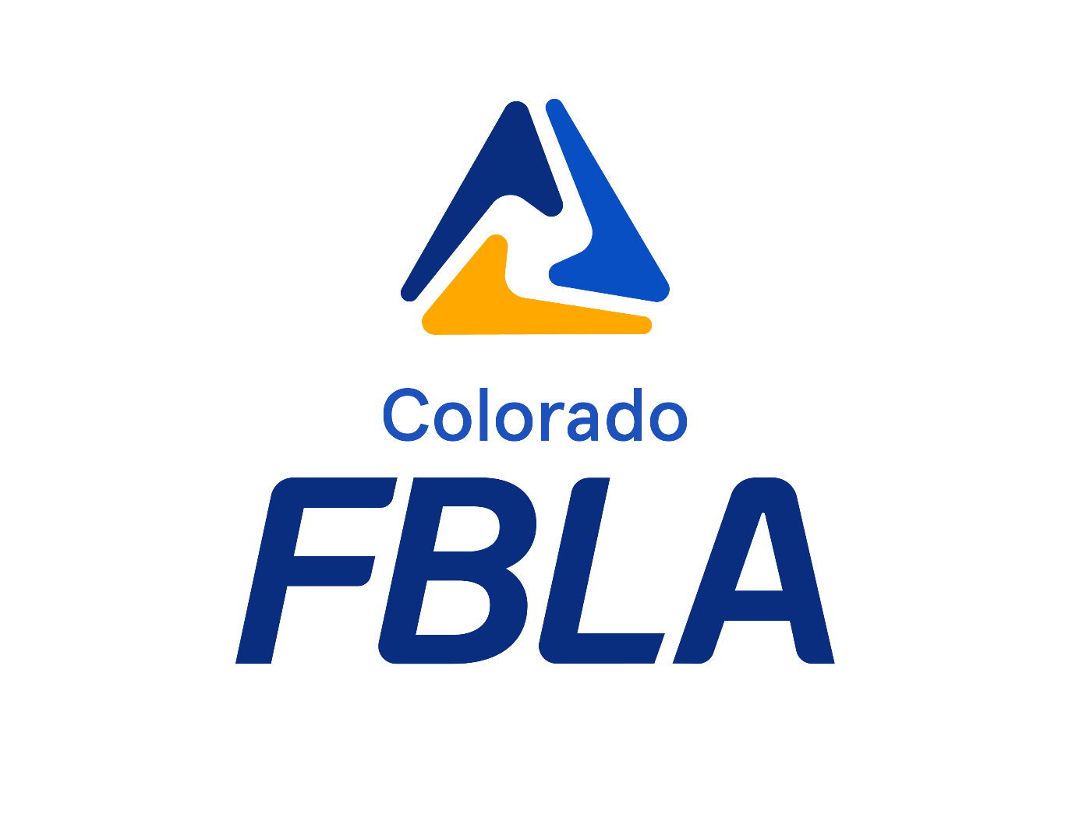

District 7 Leadership Conference
January 30, 2024
Call to Conference

Table of Contents
Adviser Checklist to Prepare for District Leadership Conference 2
District Leadership Conference Deadline Checklist 2
General Information 3
Contact Information 3
Conference Registration 3
Payments 4
Tentative Conference Schedule of Events 4
Release & Certification Forms 4
Competitive Events 4
Event Entries 4
Online Testing 4
Prejudged Events 4
Production Events 5
Policies 5
Awards & Recognition 6
State Leadership Conference 6
State Qualifier Policies 6
Dress Code 10
FAQs 11
Colorado FBLA Code of Conduct 13
Chapter Certification Form 14

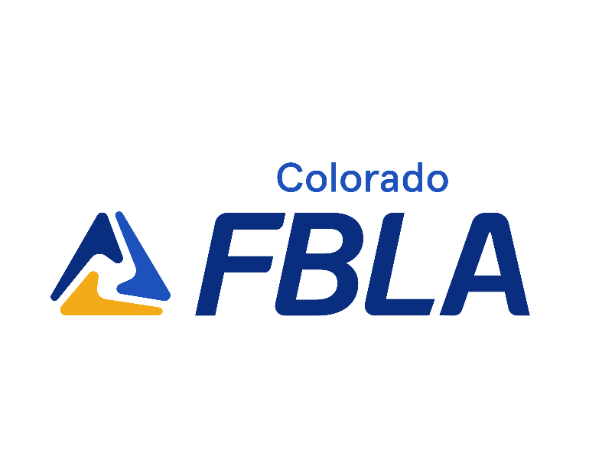

Adviser Checklist to Prepare for District Leadership Conference
Set chapter deadlines for registration and payment
Submit school district paperwork information
Provide members with necessary conference information, including cost
Send a letter to parents with event details
Register all members, advisers for the conference by the deadline
Print e-mailed invoice and check, double-check, triple-check for accuracy
Submit invoice to bookkeeper for payment
Mail conference payment
Follow the deadline checklist for all District Leadership Conference
Review District Leadership Conference tentative agenda with attending members
Discuss State Leadership Conference information with members, so they are prepared if they qualify

District Leadership Conference Deadline Checklist
Date | Deadline | Notes
December 1 | Membership Deadline  Membership Payment Deadline | connect.fbla.org
By December 5 | Registration Opens | https://app.gobluepanda.com/ - select Login with FBLA Connect and use your FBLA Connect credentials
December 15 | Registration Deadline
December 16-20 | Registration Changes or Additions | Changes: $10 per member  Additions: Registration Fee + $10 per member
After December 20 | NO registration changes or additions are allowed | THIS WILL BE STRICTLY INFORCED THIS YEAR
January 30, 2024 | Payment Received Deadline | Payments should be made to:  La Junta High School  C/O District 7 FBLA  1817 Smithland Ave, La Junta CO 81050  Credit Cards are accepted but will incur a 4% convenience Fee
January 11, 2024 | Pre-Judge Submissions | Events: Business Ethics, Business Financial Plan, Business Plan, Digital Animation, Digital Video Production, Future Business Educator, Future Business Leader, Job Interview
January 18, 2024 | Production Submissions | Events: Computer Applications, Database Design & Applications, Spreadsheet Applications, Word Processing
January 15 to January 25, 2024 | Online Testing Window | Tests available from 7 am to 7 pm
January 18, 2024 | Business Achievement Awards Completion Deadline for District Recognition | https://www.fbla-pbl.org/divisions/fbla/fbla-education/
January 25, 2024 | Grading Day | D7 Advisers Grade Production events @ La Junta HS 1pm to 4 pm
January 30, 2024 | District Leadership Conference | Otero Junior College

General Information
Date: Tuesday January 30, 2024
Location: Otero College
Cost: $30 per member, $15 per adviser/chaperone, $30 Chapter Fee

Registration | Cost | Cost | Cost
Deadline (Received) | December 15 | December 16-20 | After December 20
Registration (includes online testing, competition materials, awards, conference materials) | $30 | Changes: $10 per member  Additions: Registration Fee + $10 per member | No Changes or additions available after December 20th
How to Register | https://app.gobluepanda.com/ | https://app.gobluepanda.com/ | Not available

Attendee Information Needed to Register
Name
Competitive Event
College Tour to attend (The students will each attend up to 2 college pathway tours at Otero)

Required Forms
Multiple Release Form – completed form from each member (adviser keeps)
Certification Form – completed form from each adviser (turned in at registration)

Registration Deadlines
Registration Opens: By December 5
Registration Deadline: December 15
Late Registration: December 16-20, any changes will be $10 per member, any additions will be the registration fee + $10 per member
After December 20: No changes may be made to the District Leadership Conference registration
Payment Received Deadline: January 30, 2024

Contact Information
Name | Title | E-mail
Shawna Frankmore | Board Member | sfrankmore@lajunta.k12.co
Brisa Zubia | State Officer | brisa.zubia@granadaschools.org
Corntey Beshara | District Adviser | cortney.beshara@granadaschools.org

Conference Registration
https://app.gobluepanda.com/ - click Login with FBLA Connect, and use your same credentials. Select Colorado FBLA from the dropdown menu at the top, and then begin your registration for the District Leadership Conference.

Eligibility
To be eligible to attend and compete, members must be registered with National FBLA by midnight, December 1st. FBLA Advisers – you must open your invoice in FBLA Connect and select your method of payment by midnight, December 1st for your members to be considered active.

Registration Refunds
No registration refunds will be processed after the registration deadline.

Payments
Payment Received Deadline: January 30, 2024

Checks
Checks can be made out to District 7 FBLA and mailed to: La Junta Jr/Sr High School, 1817 Smithland Ave, La Junta, CO 81050

No refunds will be processed after the registration deadline.

Tentative Conference Schedule of Events
Registration will begin at 7:30 am in Ed Stafford Theatre will opening session to begin by 8 am. Awards to start around 1 pm. The official schedule will be released in January 2024.

Release & Certification Forms
All members must have completed Multiple Release Forms on file prior to the beginning of the conference. Keep the release forms with you. A certification form should be completed and submitted during conference registration.

Competitive Events

Event Entries
By Member: Each member can enter in a maximum of two events. Only one can be a “live”, membership entry based, non-testing event (shown in yellow highlights). Check out the Competitive Events List-Districts or the chart in this document for more details.

By Chapter: For chapter limitations, it depends on your chapter membership. Refer to the Colorado Events List-Districts.
1-49 members: 3 entries
50-100 members: 4 entries
101-150 members: 5 entries
151+ members: 6 entries

Online Testing
Online Testing Window: January 15 through January 25, 2024
Online Testing Timing: 7:00 am – 7:00 pm during the testing window
Information about the online testing and production events will be sent to advisers the beginning of January. Please ensure computers with internet access are available during this window for your students to test.

Procedural Reminder: Team objective tests are taken individually by each team member. The scores of all team members will be averaged to determine the average team score. Any team member who does not sign in within 15 minutes of other team members and take the test will be removed from the team and prevented from advancing to the next level of competition.

Prejudged Events
Deadline: January 11, 2024
By 11:59 pm, advisers submit the components of the events listed below. Competitors must complete all portions of competitions to qualify for the next level of competition.

Events with a pre-judge component:
Event | Pre-judge Component
Business Ethics | Executive Summary
Business Plan | Report (PDF)
Digital Animation | URL
Digital Video Production | URL
Future Business Educator | Lesson Plan (PDF)
Future Business Leader | Cover Letter, Resume (PDF)
Job Interview | Cover Letter, Resume (PDF)

Production Events
Deadline: January 18, 2024
Information will be sent to advisers via email the beginning of January. Competitors must complete all portions of competitions to qualify for the next level of competition.

Production Events:
Computer Applications
Database Design & Applications
Spreadsheet Applications
Word Processing

All production events will have a 50-minute online test and an additional allotment of time to complete the production elements. Competitors must complete all portions of competitions to qualify for the next level of competition.

Policies
The national guidelines will be followed for rating sheets.

Timing for presentations may vary. All information regarding the presentation times for events will be communicated through emails.

Role Play event scoring: The preliminary round will have a weighted score. 75% of each team’s overall preliminary score will be based on a team’s performance score and the other 25% of each team’s overall preliminary score will be based on the team’s objective test score.

No substitutions are allowed in between the test and role play rounds. Competitors must complete all portions of competitions to qualify for the next level of competition.

Awards & Recognition

Business Achievement Awards
Business Achievement Awards is an opportunity for individual members to be recognized for enhancing their leadership skills, expanding their business knowledge and contributing to their local communities. There are four levels to the Business Achievement Awards: Contributor, Leader, Advocate and Capstone. Learn more at this link.

At our District Leadership Conference, we will recognize the Contributor Award level of the Business Achievement Awards. Complete the award by January 18, 2024 for recognition.

State Leadership Conference
The top four competitors in each “live” competition, and the top five competitors in each testing-only competition, are eligible to attend and compete at the 2024 State Leadership Conference, held April 1-3. More information about State Leadership Conference will be posted online on the state website.

State Qualifier Policies
If a student would qualify for the State Leadership Conference in two events, the student's adviser must notify district leadership ASAP which event the student wishes to enter at the State Leadership Conference.
Team Events: The maximum registered number on the team must be maintained; for example, a team of three cannot be substituted in for a registered team of two.
Are Substitutions Allowed? Substitution Policy:
INDIVIDUAL/TEAM EVENTS. Only Team Substitutions Allowed, With Exceptions. If competing as a team that does not require a pre-judged component (see below), you may substitute one (1) member of a team originally comprised of 2 or 3 members. If competing as an individual, no substitutions are allowed, and his or her spot is forfeited to the next eligible competitor.
INDIVIDUAL EVENTS. No. Substitutions are not allowed for individual events. If an individual cannot participate in the next level of competition, his or her spot is forfeited to the next eligible competitor.
PARLIAMENTARY PROCEDURE. Yes, With Exceptions. You may make substitutions if at least two (2) members of a team of 4, or three (3) members from a team of 5 remain on the team that advance to the next level of competition. Maximum number of substitutions allowed is two (2).
CHAPTER EVENTS. Yes. Substitutions are allowed for chapter events with a presentation component if the chapter participates in the next level of competition.
PREJUDGED EVENTS. No. Substitutions are not allowed for prejudged events. However, a team may drop a member if allowed in the event guidelines. If an individual or team cannot participate in the next level of competition, their spot is forfeited to the next eligible individual or team.
ROLE PLAY EVENTS. No substitutions are allowed in between the test and role play rounds.

2023-24 Colorado FBLA Competitive Events Elements List
Member Event Limit: 2 events (only one can be a “live”, membership entry based, non-testing event – in yellow highlights)
*Individual, Team or Chapter Events – Teams can be made up of 1, 2 or 3 participants, unless otherwise noted in parenthesis. Chapter events can have 1, 2 or 3 participants present the project.
**Membership Based: 0-49 chapter members – 3 entries per chapter, 50-100 chapter members – 4 entries per chapter, 101-150 chapter members – 5 entries per chapter, 151+ chapter members – 6 entries per chapter
Event | Grade | Type | I/T/C*  (#) | Chapter  Entries** | State  Qualifiers | Notes
Accounting I | 9-12 | Online Test | I | Unlimited | Top 4
Accounting II | 9-12 | Online Test | I | Unlimited | Top 4
Advertising | 9-12 | Online Test | I | Unlimited | Top 4
Agribusiness | 9-12 | Online Test | I | Unlimited | Top 4
American Enterprise Project | 9-12 | Prejudge Report &  Presentation | C | 1 per chapter |  | State only event – no  district competition
Banking & Financial Systems | 9-12 | Online Test & Role Play | T (1-3) | Membership Based | Top 4
Broadcast Journalism | 9-12 | Presentation (Equipment) | T (1-3) | Membership  Based | Top 4
Business Calculations | 9-12 | Online Test | I | Unlimited | Top 4
Business Communication | 9-12 | Online Test | I | Unlimited | Top 4
Business Ethics | 9-12 | Online Test, Prejudge,  Presentation | T (1-3) | Membership  Based | Top 4
Business Law | 9-12 | Online Test | I | Unlimited | Top 4
Business Management | 9-12 | Online Test & Role Play | T (1-3) | Membership  Based | Top 4
Business Plan | 9-12 | Prejudge Report &  Presentation | T (1-3) | Membership  Based | Top 4
Client Service | 9-12 | Role Play | I | Membership  Based | Top 4
Coding & Programming | 9-12 | Demonstration | T (1-3) | Membership Based | Top 4
Community Service Project | 9-12 | Prejudge Report &  Presentation | C | 1 per chapter |  | State only event – no  district competition
Computer Applications | 9-12 | Production & Online Test | I | Unlimited | Top 4
Computer Game & Simulation Programming | 9-12 | Demonstration | T (1-3) | Membership Based | Top 4
Computer Problem Solving | 9-12 | Online Test | I | Unlimited | Top 4
Cyber Security | 9-12 | Online Test | I | Unlimited | Top 4
Data Analysis | 9-12 | Presentation (Equipment) | T (1-3) | Membership  Based | Top 4
Database Design & Apps | 9-12 | Production & Online Test | I | Unlimited | Top 4
Digital Animation | 9-12 | Prejudge Project &  Presentation | T (1-3) | Membership  Based | Top 4
Digital Video Production | 9-12 | Prejudge Project &  Presentation | T (1-3) | Membership  Based | Top 4
Economics | 9-12 | Online Test | I | Unlimited | Top 4
Electronic Career Portfolio | 9-12 | Presentation (Equipment) | I | Membership  Based | Top 4
Entrepreneurship | 9-12 | Online Test & Role Play | T (1-3) | Membership  Based | Top 4
Financial Statement Analysis | 9-12 | Presentation | T (1-3) | Membership  Based | Top 4
Future Business Educator | 9-12 | Prejudge & Presentation (Equipment) | I | Membership Based | Top 4
Future Business Leader | 9-12 | Objective Test, Prejudge &  Interview | I | Membership  Based | Top 4

Graphic Design | 9-12 | Presentation (Equipment) | T (1-3) | Membership  Based | Top 4
Health Care Administration | 9-12 | Online Test | I | Unlimited | Top 4
Help Desk | 9-12 | Online Test & Role Play | I | Membership Based | Top 4
Hospitality & Event Management | 9-12 | Online Test & Role Play | T (1-3) | Membership  Based | Top 4
Human Resource Management | 9-12 | Online Test | I | Unlimited | Top 4
Impromptu Speaking | 9-12 | Speech | I | Membership  Based | Top 4
Insurance & Risk Management | 9-12 | Online Test | I | Unlimited | Top 4
International Business | 9-12 | Online Test & Role Play | T (1-3) | Membership  Based | Top 4
Introduction to Business  Communication | 9-10 | Online Test | I | Unlimited | Top 4
Introduction to Business  Concepts | 9-10 | Online Test | I | Unlimited | Top 4
Introduction to Business Presentation | 9-10 | Presentation (Equipment) | T (1-3) | Membership  Based | Top 4
Introduction to Business Procedures | 9-10 | Online Test | I | Unlimited | Top 4
Introduction to Event Planning | 9-10 | Online Test & Role Play | T (1-3) | Membership  Based | Top 4
Introduction to FBLA | 9-10 | Online Test | I | Unlimited | Top 4
Introduction to Financial Math | 9-10 | Online Test | I | Unlimited | Top 4
Introduction to Information Technology | 9-10 | Online Test | I | Unlimited | Top 4
Introduction to Marketing Concepts | 9-10 | Online Test | I | Unlimited | Top 4
Introduction to Parliamentary Procedure | 9-10 | Online Test | I | Unlimited | Top 4
Introduction to Programming | 9-10 | Presentation (Equipment) | T (1-3) | Membership  Based | Top 4
Introduction to Public Speaking | 9-10 | Speech | I | Membership  Based | Top 4
Introduction to Social Media Strategy | 9-10 | Presentation (Equipment) | T (1-3) | Membership  Based | Top 4
Job Interview | 9-12 | Prejudge & Interview | I | Membership Based | Top 4
Journalism | 9-12 | Online Test | I | Unlimited | Top 4
Local Chapter Annual Business Report | 9-12 | Prejudge Report &  Presentation | C | 1 per chapter |  | State only event – no  district competition
Management Information Systems | 9-12 | Online Test & Role Play | T (1-3) | Membership  Based | Top 4
Marketing | 9-12 | Online Test & Role Play | T (1-3) | Membership Based | Top 4
Mobile Application Development | 9-12 | Demonstration | T (1-3) | Membership  Based | Top 4
Network Design | 9-12 | Online Test & Role Play | T (1-3) | Membership  Based | Top 4
Networking Infrastructures | 9-12 | Online Test | I | Unlimited | Top 4
Organizational Leadership | 9-12 | Online Test | I | Unlimited | Top 4
Parliamentary Procedure | 9-12 | Online Test & Role Play | T (4-5) | Membership  Based | Top 4

Partnership with Business Project | 9-12 | Prejudge Report &  Presentation | C | 1 per chapter |  | State only event – no  district competition
Personal Finance | 9-12 | Online Test | I | Unlimited | Top 4
Public Policy & Advocacy | 9-12 | Online Test | I | Unlimited | Top 4
Public Service Announcement | 9-12 | Presentation (Equipment) | T (1-3) | Membership Based | Top 4
Public Speaking | 9-12 | Speech | I | Membership Based | Top 4
Sales Presentation | 9-12 | Presentation (Equipment) | T (1-3) | Membership  Based | Top 4
Securities & Investments | 9-12 | Online Test | I | Unlimited | Top 5
Social Media Strategies | 9-12 | Presentation (Equipment) | T (1-3) | Membership  Based | Top 4
Sports & Entertainment Management | 9-12 | Online Test & Role Play | T (1-3) | Membership  Based | Top 4
Spreadsheet Applications | 9-12 | Production & Online Test | I | Unlimited | Top 4
Supply Chain Management | 9-12 | Online Test | I | Unlimited | Top 4
UX Design | 9-12 | Online Test | I | Unlimited | Top 4
Visual Design | 9-12 | Presentation (Equipment) | T (1-3) | Membership  Based | Top 4
Website Coding & Development | 9-12 | Demonstration | T (1-3) | Membership  Based | Top 4
Website Design | 9-12 | Demonstration | T (1-3) | Membership  Based | Top 4
Who's Who in FBLA | 12 | Prejudge | I | Unlimited |  | State only event – no district competition
Word Processing | 9-12 | Production & Online Test | I | Unlimited | Top 4

Dress Code
The FBLA National Dress Code will be in effect.

FBLA members and advisers should develop an awareness of the image one’s appearance projects. The purpose of the dress code is to uphold the professional image of the association and its members and to prepare members for the business world.
Appropriate attire is required for members during competitive events.
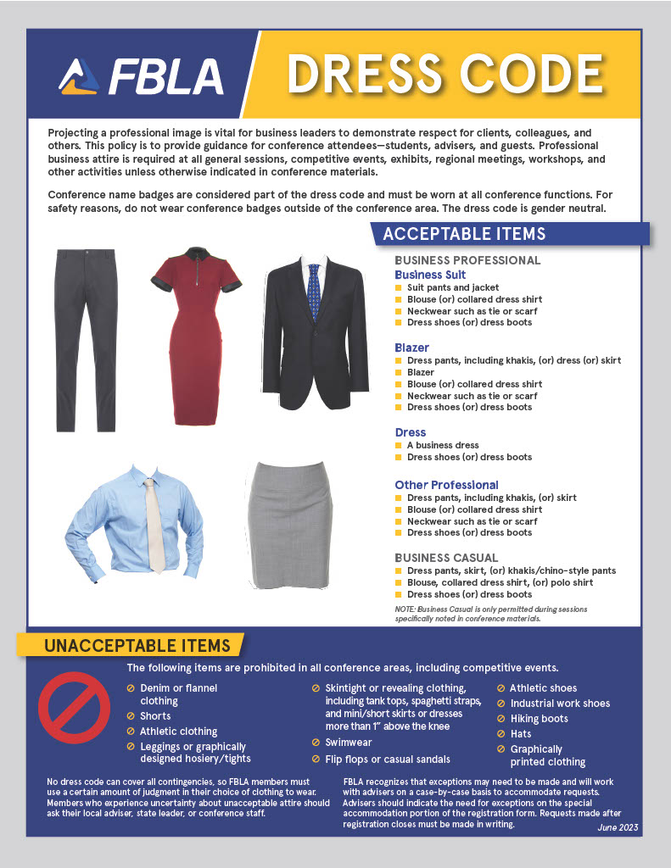

FAQs
Q: Where do I go to register?
A: Go to app.bluepanda.com to register for your District Leadership Conference. Click Login with FBLA Connect, and use your same credentials. Select Colorado FBLA from the dropdown menu at the top, and then begin your registration for the District Leadership Conference. Follow the DLC Registration Tutorial for step-by-step instructions.

Q: What is my username and password?
A: You will login using the same credentials you use to access FBLA Connect. If you cannot login to FBLA Connect, please submit a Help Desk ticket from connect.fbla.org.

Q: I have a student that needs accommodations.
A: Please list these accommodations in the registration system. Follow the DLC Registration Tutorial for step-by-step instructions.

Q: How do I know that my registration has been received?
A: Make sure to click SUBMIT at the end. If you have received an e-mail confirmation, you are officially registered. Follow the DLC Registration Tutorial for step-by-step instructions.

Q: When is my District Leadership Conference and how do I pay?
A: Read your district’s Call to Conference, found online in the District Conferences tab, under Events, on the Colorado FBLA website.

Q: In how many events can a student participate?
A: No more than two, only one can be a “live” event (highlighted in the Event Element and Limitation list). Refer to the Competitive Events List - District.

Q: How many entries does my chapter receive for each event?
A: For testing events, chapters receive unlimited entries. For membership-based entries, it depends on your chapter membership. Refer to the Competitive Events List – District.
- 1-49 members: 3 entries
- 50-100 members: 4 entries
- 101-150 members: 5 entries
- 151+ members: 6 entries

Q: What are the rules on if a member competed in the event before?
A: The national guidelines are followed. Members may compete in an event more than once if they have not previously placed in the top ten of that event at the National Leadership Conference. If a member places in the top ten of an event at NLC, they are no longer eligible to compete in that event. This eliminates the exceptions for team events that were previously in place, as this change will now affect all events.

Q: Help! I’ve logged in and don’t see a member!
A: The member isn’t really a member. The membership registration and payment deadline was December 1st. You may still register the student as an FBLA member on the national website. Contact Molly Davis to add them to the DLC registration list by December 15th for a $10 fee per late member – molly.davis@cccs.edu.

Q: Help! I can’t log in!!
A: Click the “Login with FBLA Connect” button from Blue Panda, and then use the same credentials you use when logging into the FBLA Connect membership system. Follow the DLC Registration Tutorial for step-by-step instructions. If you are still unable to log in, you may be blocked from registering because of an owed balance. Contact Molly Davis at molly.davis@cccs.edu.

Q: Where is the information on taking tests?
A: Tests will all take place online, prior to the District Leadership Conference. Information about logging in to take tests will be sent out in late December/early January via email.

Q: How long are the online tests?
A: Each test is timed and will time out after 50 minutes. This is a change from last year.

Q: Can students start the test on one day and finish it on another?
A: No. Students must take the test in one sitting.

Q: What if I have several students on a team? Do they each take an individual test or do they collaboratively take one test?
A: The students will take the test individually. Team objective tests are taken individually by each team member. The scores of all team members will be averaged to determine the average team score. Any team member who does not sign in within 15 minutes of other team members and take the test will be removed from the team and prevented from advancing to the next level of competition.

Q: Where is the information on the production events?
A: The production part of four competitions (Computer Applications, Database Design & Applications, Spreadsheet Applications, Word Processing) will all take place prior to the District Leadership Conference. Information about production tests will be sent out in January via email.

Q: Do production events have to take a test?
A: Yes. For Computer Applications, Database Design & Applications, Spreadsheet Applications, Word Processing, students will need to budget their time to take a 50-minute-long test, in addition to completing their production events in the allotted amount of time for the production assessment.

Colorado FBLA Code of Conduct
The purpose of the Code of Conduct is to ensure that FBLA members who attend a conference are aware of expected behavior. It is the adviser’s responsibility to discuss the form with the members and stress the importance of abiding by the rules. Colorado FBLA is proud of its reputation and encourages advisers to closely monitor students at all conferences. Advisers must have a signed Code of Conduct in their possession at all FBLA activities and must submit a Certification Form certifying that all members have read and signed the Verification Form.

CONDUCT POLICIES AND PROCEDURES FOR COLORADO FBLA
The following conduct policies reflect minimum behavioral standards for Colorado FBLA members. The policies are in effect for all delegates who are attending any Local, State or National FBLA function. The term “delegate” shall mean any FBLA member.

- Defacing of public property—any damage to or loss of property or furnishings of the properties being utilized for meeting purposes will be paid for by the individual or chapter responsible.
- Delegates shall keep their adult advisers informed of their activities and whereabouts at all times.
- Delegates will not be allowed to leave the conference site at any time without adult supervision.
- Members will be prohibited from participation without local supervision provided by the chapter or school. For the National Leadership Conference a designated local adviser or parent will be expected to accompany the participants.
- Delegates shall not use their own cars or ride in cars belonging to others during the conference unless accompanied by an adviser or other responsible adult.
- Alcoholic beverages and controlled or illegal substances (drugs) of any form are not allowed. These items must not be used or possessed at any time, or under any circumstances. Use or possession of such substances may subject the delegate to criminal prosecution.
- Use of tobacco in any form by an FBLA member is prohibited, including e-cigarettes.
- Participants will NOT be admitted to conference activities and competitive events if in violation of the dress code. Furthermore, competitors will not walk on stage during awards sessions if observed violating the dress code.
- Observe the curfews as listed in the conference program. Curfew is defined as being in your own assigned room by the designated hour.
- Members of the opposite sex are not allowed in sleeping rooms in hotels or motels unless the door is WIDE OPEN or the chapter adviser or responsible adult is present in the room.
- Colorado FBLA photographers and videographers will be taking photos and videos throughout the conference for use in any manner FBLA deems appropriate including, but not limited to, publishing in FBLA publications, on the FBLA website, and in connection with competitive performance events. By attending the conference, you grant FBLA the right, without approval, to photograph, record, use, and edit your photograph, video, image, likeness, appearance, performance, and any other indicia of identity, in any format whatsoever, and to publish, disseminate, exhibit, publicly display, give, sell, and/or transfer the same in any and all forms of media or distribution now known or hereafter discovered or developed (including, but not limited to, print media, Internet, Web casting, video streaming, television or radio), for the use of FBLA, its affiliates, or any individual, organization, business, publication, network or other third party, in perpetuity, without payment or any consideration.

DISREGARDING OR VIOLATING THE CODE OF CONDUCT
Delegates who disregard or violate this code will be subject to disciplinary action, including, but not limited to, competitive event disqualification, forfeiture of privileges to attend further events, confinement to your hotel room, dismissal from the conference, and being sent home at your own expense. Parents and/or guardians will be notified and FBLA reserves the right to notify law enforcement. Any Code of Conduct violation must be brought to the attention of the state adviser prior to the conclusion of the conference.

Chapter Certification Form

The FBLA members of ___________________________________ School have read the Code of Conduct, Dress Code and completed the CTSO Multiple Release Forms.

In addition, we certify that all staff provided by the school district and attending this conference with the Colorado CTSOs have completed and passed a Criminal Background Check and Sexual Abuse Prevention Training.

Our chapter has an emergency plan. This plan has been communicated with attending members, parents and administrators.

__________________________________ __________________________________
(Adviser Printed Name) (Adviser Signature) (Date)

__________________________________ __________________________________
(School Administrator Printed Name) (School Administrator Signature) (Date)

This form is to be submitted during on-site conference registration. Do not send individual forms to the state. Individual forms must be in possession of the adviser.

