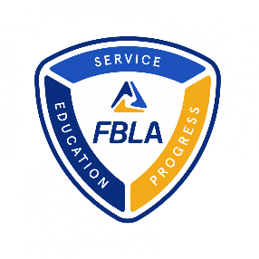
Adviser Monthly Implementation Guide
MEMBERSHIP MANAGEMENT
- Register returning and new members for your chapter at my.FBLA.
- Sign the Data Usage Agreement
- Share chapter news or an article pitch for a future issue of Tomorrow’s Business Leader. We are particularly interested in stories and article ideas surrounding the topics of community service projects, DEI, and Business Ethics.
Submit Chapter News
- Register for NFLC
  - Don’t forget to make housing accommodations!
NFLC Details
CHAMPION CHAPTER
- Set an action plan to participate in the Champion Chapter Program. (NOTE: You do not need to participate in ALL sections to qualify for Champion Chapter so long as you accumulate 2,000+ by the challenge end date)
  - Shaping Success – Begin Shaping Success activities
Deadline to submit Shaping Success: November 10 Form Available 10/1
  - Service Season – Review Service Season activities
Deadline to submit Service Season: December 31 Form Available 11/11
RECRUITMENT
- Create a membership committee to focus on new ways to bring in and retain members
- Share the digital copy of the September issue of Tomorrow’s Business Leader with your students
BUSINESS ACHIEVEMENT AWARDS
- Get students connected and acclimated with the FBLA Learning Center
- Explore the Classroom Connections for Advisers
BAA Adviser Resources
STUDENT CHALLENGES
- Register for Virtual Business Challenges Registration Begins on October 22
- Register for Stock Market Game Registration Begins on October 10
MARCH OF DIMES
- Register for and attend the October 19 March of Dimes Kickoff Webinar
COMPETITIVE EVENTS
- Work with members to identify their competitive event focus

(FBLA High School Division)
OCTOBER

