2024 Colorado FBLA Middle School
Call to Conference

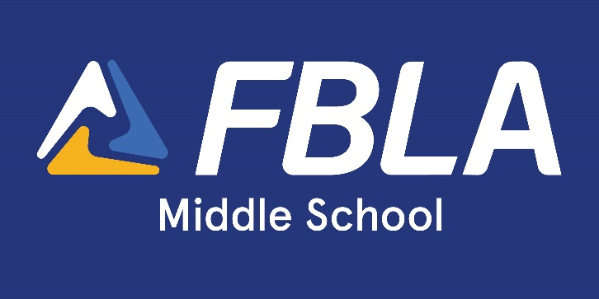

March 5, 2024
Riverdale Regional Park, Brighton, CO

Table of Contents
Checklist to Prepare for State Leadership Conference 2
State Leadership Conference Deadline Checklist 3
General Information 3
Cost: 3
Conference Registration Information 4
Payments 4
Tentative Schedule 4
Parking 5
Emergency Notification System: Remind 5
Special Accommodations 5
Lunch 5
Competitive Events 6
Event Entries 7
National Leadership Conference 8
Frequently Asked Questions 8
Dress Code 8
Colorado FBLA Code of Conduct & Release Forms 9

Checklist to Prepare for State Leadership Conference
- Set chapter deadlines for registration and payment
- Submit school district paperwork and transportation information
- Determine member cost to attend with your chapter, including registration fees, meals, travel, etc.
- Provide members with necessary conference information, including cost
- Send a letter to parents with event details
- Discuss dress code requirements with members
- Collect member payment before registration deadline
- Register all members, advisers, chaperones for the conference by the deadline
- Print e-mailed invoice and check, double-check, triple-check for accuracy
- Submit invoice to bookkeeper for payment
- Mail conference payment to Colorado FBLA
- Follow the deadline checklist for all State Leadership Conference forms
- Review State Leadership Conference tentative agenda with attending members
- Ensure proper dress attire before departure
- Ensure all Multiple Release Forms are properly completed, bring copies with you to State Leadership Conference (these will NOT be turned in to Colorado FBLA)
- Complete the certification form to turn in at registration
- Sign up for Emergency Notification System (Remind)
- Have all attendees follow and like Colorado FBLA on social media sites to receive conference updates and emergency information during the conference
- Discuss National Leadership Conference information with members, so they are prepared if they qualify

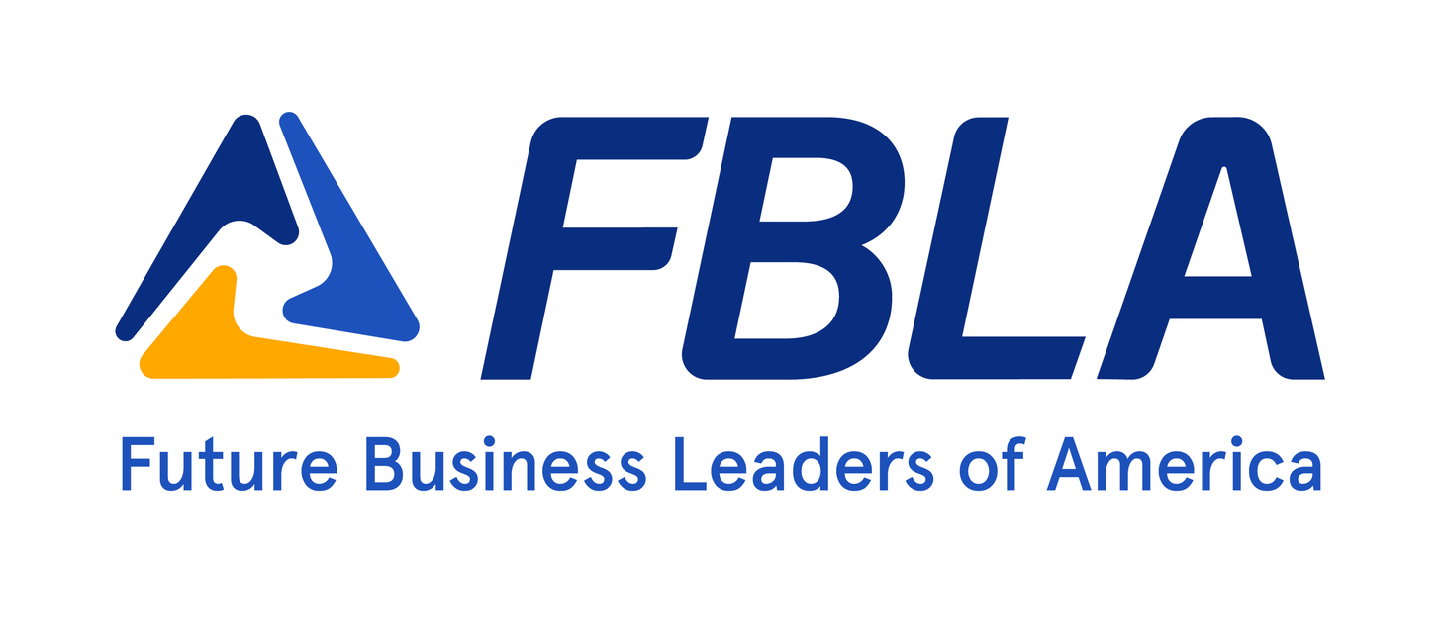

State Leadership Conference Deadline Checklist
Date | Deadline | Notes
ASAP | Sign up for Notification  System (Remind) | https://www.remind.com/join/mlfbl17
January 12 | Membership Registration  Deadline | connect.fbla.org > find tutorials posted on the Membership Tab of the Adviser Resources page, www.coloradofbla.org/adviser-resources
January 15 | Registration Opens | https://app.gobluepanda.com/Login > select Login with FBLA Connect and use the same credentials
February 2 | Early Bird Registration  Deadline | https://app.gobluepanda.com/Login
February 9 | Regular Registration  Deadline | https://app.gobluepanda.com/Login
February 16 | LEAD Awards Recognition Deadline | https://www.fbla-pbl.org/divisions/fbla-middle-level/education-programs/
February 19  – March 1 | Online Testing Window | Instructions to follow, after conference registration closes
March 1 | Payment RECEIVED Deadline | 9101 E Lowry Blvd, Denver, CO 80230
March 5 | Certification Form | Turn in during registration

General Information
State Leadership Conference Description: While attending the Colorado FBLA Middle School State Leadership Conference, members will have the opportunity to participate in a Junior Achievement program, competitive events, and an awards ceremony.

Date: Wednesday, March 5, 2024
Location: Riverdale Regional Park, 9755 Henderson Rd, Brighton, CO 80601

Cost:
Registration | Early Bird Cost | Regular Cost | Late Cost*
Deadline | February 2 | February 9 | After Feb 9
Registration (includes facilities & equipment, online testing, competition materials, lunch,  awards, conference materials) | $40 | $65 | $80
*To register members after the registration deadline, e-mail molly.davis@cccs.edu. Late registration not guaranteed.

Attendee Information Needed to Register
- Name
- Competitive Event
- Lunch choice: turkey sandwich, ham sandwich, roast beef sandwich, or veggie sandwich
- Any special testing accommodations or dietary needs (lunch option will be adjusted if any dietary needs are listed)

Required Forms
- Multiple Release Form – on page 10, completed form from each member (adviser keeps)
- Certification Form – on page 11, (adviser turns in during on-site registration)

Conference Registration Information

https://app.gobluepanda.com/Login > select Login with FBLA Connect and use the same credentials. Select this conference from the dropdown menu in the upper left-hand corner.

Registration Deadlines
- Registration Opens: January 15
- Early Bird Registration Deadline: February 2
- Regular Registration Deadline: February 9
- Payment RECEIPT Deadline: March 1

Eligibility
Chapter advisers, parents, administrators are eligible to attend. Every person attending the State Leadership Conference MUST be registered and paid and have a name badge (this will be given to you on site during registration check-in).

Chaperone Ratio
A ratio of one adult for every 10 members is recommended. In the event your district has a different chaperone policy, your district’s policy should be followed. When attending Colorado FBLA conferences and events, advisers are expected to provide adequate supervision for his/her members. All chaperones must follow the Colorado FBLA code of conduct.

Registration Refunds
No registration refunds will be processed after the registration deadline.

Payments
Payment RECEIPT Deadline: March 1
Payments not received by March 1st will incur a 10% late fee on the amount due, up to $300.

Checks
Checks can be made out to Colorado FBLA and mailed to 9101 E Lowry Blvd, Denver, CO 80230.

Credit Card Payments
Payment by credit card is available. Select credit card during the registration process. A convenience fee of 4% will be added. This convenience fee will be charged if a credit card is used, regardless of which payment method is selected in the registration system.

Tentative Schedule
Tuesday, March 5
8:00 am Registration
8:20 am Opening Session
Programming
Lunch Competitions
2:00 pm Awards Ceremony
2:30 pm Day Concludes

Release Forms
All members must have completed Multiple Release Forms (found on page 9) on file prior to the beginning of the conference. Keep the release forms with you and complete the Certification Form (found on page 10) to turn in at registration.

Parking
Parking is free at Riverdale Regional Park.

Emergency Notification System: Remind
Colorado FBLA will be using Remind for an Emergency Notification System during the conference, as well as a way for advisers to receive alerts of any updates or changes taking place. Follow the instructions below to receive texts.

Pick a way to receive messages from Remind:
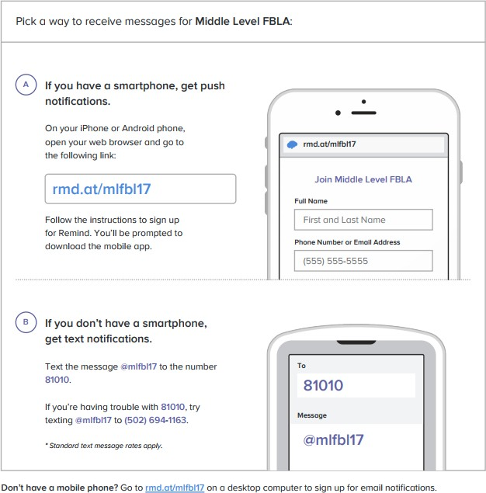

Special Accommodations
For members that require special accommodations, complete the special needs portion in the registration system. Example reasons that members may need special accommodations would include wheelchair access or interpreter services or special dietary requests.

Lunch
Lunch is included in the cost of the day.

Competitive Events
All national events will be offered at the state level.
- Annual Chapter Activities Presentation
- Business Ethics
- Business Etiquette
- Career Exploration
- Career Research
- Community Service Presentation
- Critical Thinking
- Digital Citizenship
- Elevator Speech
- Exploring Business Issues
- Exploring Computer Science
- Exploring Economics
- Exploring Technology
- FBLA Concepts
- FBLA Mission & Pledge
- Financial Literacy
- Interpersonal Communication
- Leadership
- Learning Strategies
- Marketing Mix Challenge
- Multimedia & Website Development
- Running an Effective Meeting
- Video Game Challenge

Online Testing Events
Online Testing Window: February 19 – March 1
Online testing will be offered during the online testing window. Information about the online testing will be sent to advisers by February 16th. Please ensure computers with Internet access are available during this window for your students to test.

Awards Session
The session, held at the end of the day on March 5th, will recognize the top three competitors in each event.

LEAD Awards
LEAD Awards is an opportunity for individual members to be recognized for enhancing their leadership skills, expanding their business knowledge and contributing to their local communities. There are two levels to the LEAD Awards: Explore and Aspire. Learn more at this link.

At our Conference, LEAD Awards will be recognized. Complete the award by February 16th for recognition.

Event Entries
Competitive Event guidelines and rating sheets can be found online. Each middle school member can enter in a maximum of two events: two testing events (in blue below) or one presentation event and one testing event. Event entries are limited per chapter, depending on the event.

Event | Category | Type | Event entries per Chapter | Notes
Annual Chapter Activities Presentation | Presentation with  Equipment | Chapter | 1 | 1-minute set up time
Business Ethics | Presentation with Equipment (Test) | Individual or Team | 3 | 1-minute set up time; testing is done prior to SLC
Business Etiquette | Objective Test | Individual | Unlimited | Testing is done prior to SLC
Career Exploration | Objective Test | Individual | Unlimited | Testing is done prior to SLC
Career Research | Presentation with  Equipment | Individual | 3 | 1-minute set up time
Community Service Presentation | Presentation with  Equipment | Chapter | 1 | 1-minute set up time
Critical Thinking | Presentation  without Equipment | Individual  or Team | 3 | 15-minute prep time
Digital Citizenship | Objective Test | Individual | Unlimited | Testing is done prior to SLC
Elevator Speech | Speech | Individual | 3
Exploring Business Issues | Presentation  without Equipment | Individual  or Team | 3 | 1-minute set up time
Exploring Computer Science | Objective Test | Individual | Unlimited | Testing is done prior to SLC
Exploring Economics | Objective Test | Individual | Unlimited | Testing is done prior to SLC
Exploring Technology | Objective Test | Individual | Unlimited | Testing is done prior to SLC
FBLA Concepts | Objective Test | Individual | Unlimited | Testing is done prior to SLC
FBLA Mission & Pledge | Presentation  without Equipment | Individual | 3
Financial Literacy | Objective Test | Individual | Unlimited | Testing is done prior to SLC
Interpersonal Communication | Objective Test | Individual | Unlimited | Testing is done prior to SLC
Leadership | Objective Test | Individual | Unlimited | Testing is done prior to SLC
Learning Strategies | Objective Test | Individual | Unlimited | Testing is done prior to SLC
Marketing Mix Challenge | Presentation with  Equipment | Individual  or Team | 3 | 1-minute set up time
Multimedia & Website Development | Demonstration | Individual  or Team | 3 | 1-minute set up time; Internet will be provided, but have a Plan B.
Running an Effective Meeting | Objective Test | Individual | Unlimited | Testing is done prior to SLC
Video Game Challenge | Demonstration | Individual  or Team | 3 | 1-minute set up time; Internet will be provided, but have a Plan B.

National Leadership Conference
The top two competitors in each national competition are eligible to attend and compete at the 2024 National Leadership Conference. The FBLA National Leadership Conference will be held in Orlando, Florida, June 29th - July 2nd.

Frequently Asked Questions
Q: I have a member/chaperone that backed out after the deadline, what can I do?
A: You can replace the member or chaperone so your registration number stays the same, but no refunds will be given after the registration deadline. Events may not be changed after the deadline.

Q: What meals are included in the conference fee?
A: Lunch

Q: Can my member compete in more than one event?
A: Yes. See the chart by the Competitive Events section.

Q: Does Colorado FBLA accept credit card payments?
A: Yes, you’ll be able to complete payment with a credit card in the Blue Panda registration system. Remember the 4% convenience fee that’s added to the total amount for paying via credit card.

Dress Code
The FBLA National Dress Code will be in effect. Please follow Business Professional guidelines.
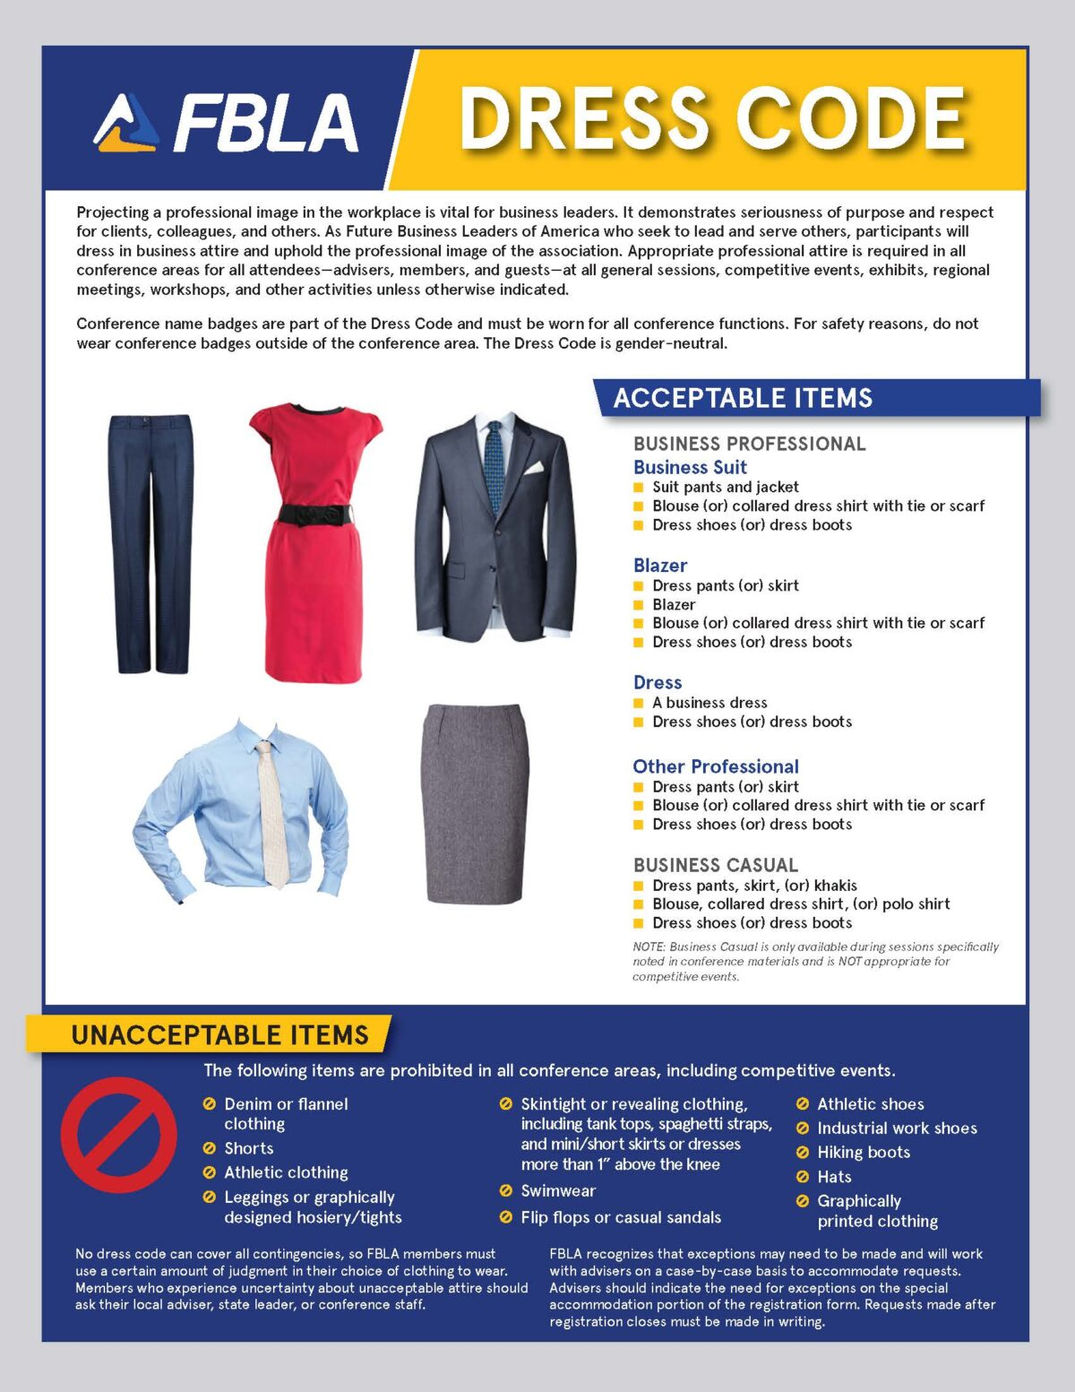

Colorado FBLA Code of Conduct & Release Forms
Colorado FBLA Code of Conduct
The purpose of the Code of Conduct is to ensure that FBLA members who attend a conference are aware of expected behavior. It is the adviser’s responsibility to discuss the form with the members and stress the importance of abiding by the rules. Colorado FBLA is proud of its reputation and encourages advisers to closely monitor students at all conferences. Advisers must have a signed Code of Conduct in their possession at all FBLA activities and must submit a Certification Form certifying that all members have read and signed the Verification Form.

CONDUCT POLICIES AND PROCEDURES FOR COLORADO FBLA
The following conduct policies reflect minimum behavioral standards for Colorado FBLA members. The policies are in effect for all delegates who are attending any Local, State or National FBLA function. The term “delegate” shall mean any FBLA member.

- Defacing of public property—any damage to or loss of property or furnishings of the properties being utilized for meeting purposes will be paid for by the individual or chapter responsible.
- Delegates shall keep their adult advisers informed of their activities and whereabouts at all times.
- Delegates will not be allowed to leave the conference site at any time without adult supervision.
- Members will be prohibited from participation without local supervision provided by the chapter or school. For the National Leadership Conference a designated local adviser or parent will be expected to accompany the participants.
- Delegates shall not use their own cars or ride in cars belonging to others during the conference unless accompanied by an adviser or other responsible adult.
- Alcoholic beverages and controlled or illegal substances (drugs) of any form are not allowed. These items must not be used or possessed at any time, or under any circumstances. Use or possession of such substances may subject the delegate to criminal prosecution.
- Use of tobacco in any form by an FBLA member is prohibited, including e-cigarettes.
- Participants will NOT be admitted to conference activities and competitive events if in violation of the dress code. Furthermore, competitors will not walk on stage during awards sessions if observed violating the dress code.
- Observe the curfews as listed in the conference program. Curfew is defined as being in your own assigned room by the designated hour.
- Members of the opposite sex are not allowed in sleeping rooms in hotels or motels unless the door is WIDE OPEN or the chapter adviser or responsible adult is present in the room.
- Colorado FBLA photographers and videographers will be taking photos and videos throughout the conference for use in any manner FBLA deems appropriate including, but not limited to,
publishing in FBLA publications, on the FBLA website, and in connection with competitive performance events. By attending the conference, you grant FBLA the right, without approval, to photograph, record, use, and edit your photograph, video, image, likeness, appearance, performance, and any other indicia of identity, in any format whatsoever, and to publish,
disseminate, exhibit, publicly display, give, sell, and/or transfer the same in any and all forms of media or distribution now known or hereafter discovered or developed (including, but not limited to, print media, Internet, Web casting, video streaming, television or radio), for the use of FBLA, its affiliates, or any individual, organization, business, publication, network or other third party, in perpetuity, without payment or any consideration.

DISREGARDING OR VIOLATING THE CODE OF CONDUCT
Delegates who disregard or violate this code will be subject to disciplinary action, including, but not limited to, competitive event disqualification, forfeiture of privileges to attend further events, confinement to your hotel room, dismissal from the conference, and being sent home at your own expense. Parents and/or guardians will be notified and FBLA reserves the right to notify law enforcement. Any Code of Conduct violation must be brought to the attention of the state adviser prior to the conclusion of the conference.

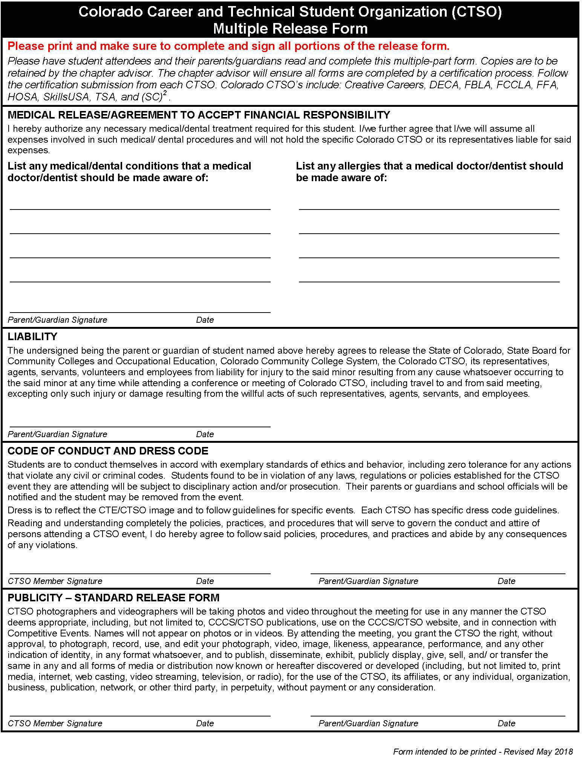

Chapter Certification Form
The CTSO members of School have read the Code of
Conduct, Dress Code and completed the CTSO Multiple Release Forms.

In addition, we certify that all staff provided by the school district and attending this conference with the Colorado CTSOs have completed and passed a Criminal Background Check and Sexual Abuse Prevention Training.

A meeting emergency plan has been created and communicated to attendees, parents of attendees and administrators.
This form is to be submitted during on-site conference registration. Do not send individual forms to the state. Individual forms must be in possession of the adviser.

(Adviser Printed Name) |  | (Adviser Signature) |  | (Date)
(School Administrator Printed Name) |  | (School Administrator Signature) |  | (Date)

